**PCB Specification FC-Sensor**

* Board Layer Stackup

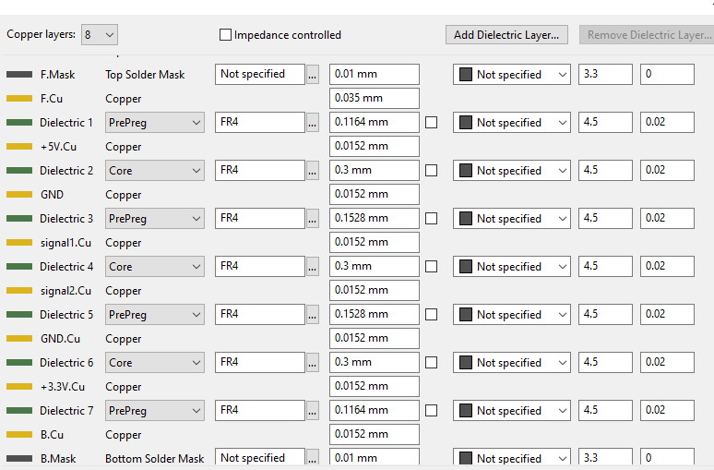

* Constraints

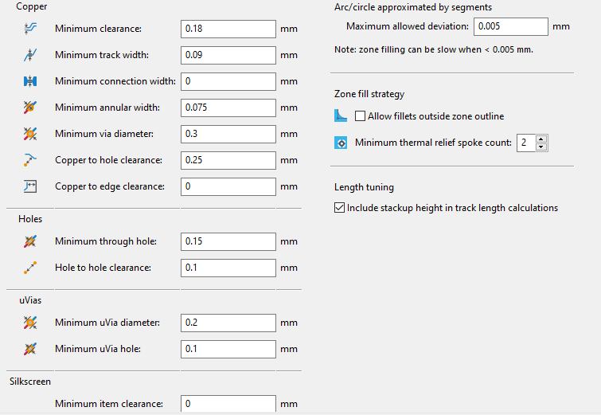

* 120ohm impedance control

It’s necessary to apply 120ohm impedance control to the following CAN traces on the layer5(signal2).

It’s necessary to apply 100ohm impedance control to the following Ethernet traces on the layer1(F.Cu), layer5(signal2), layer8(B.Cu).

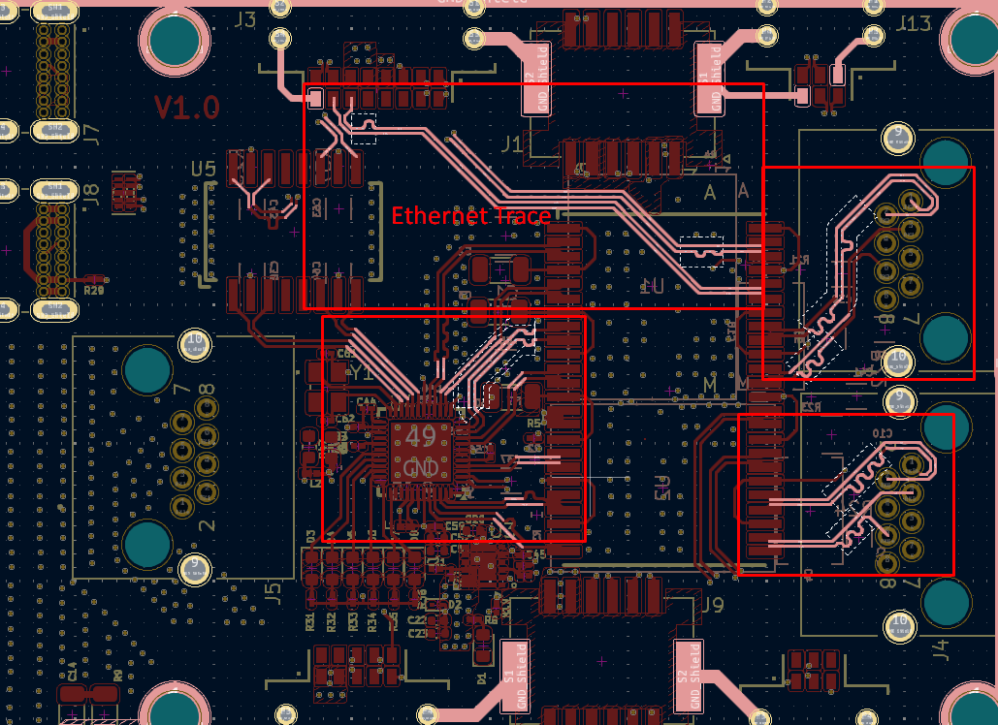

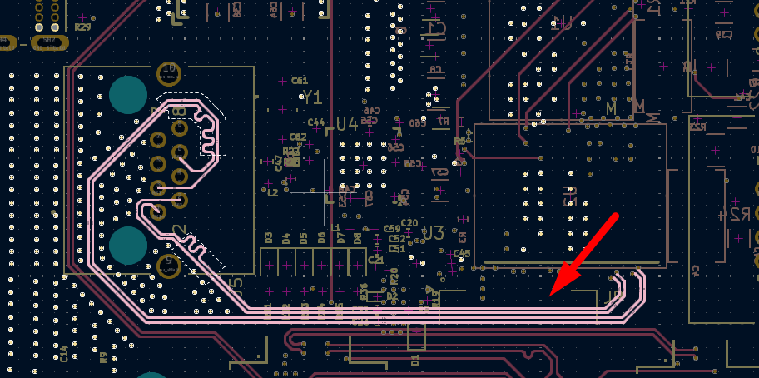

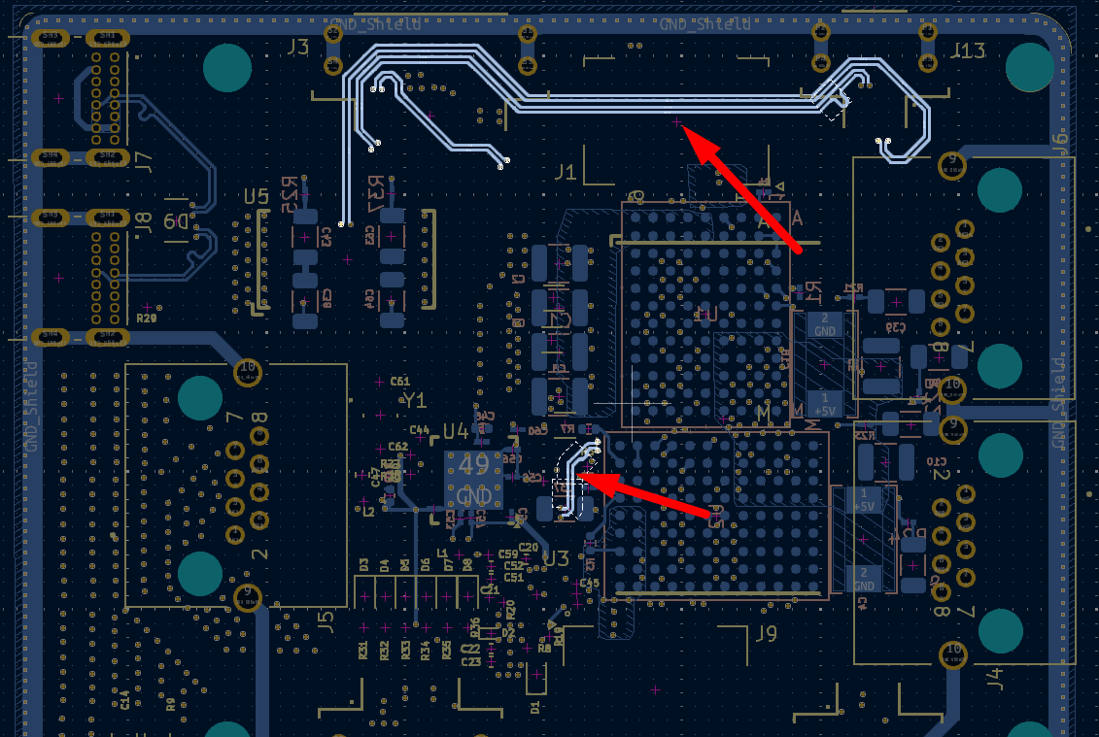

It’s necessary to apply 120ohm impedance control to the following CAN traces on the layer5(signal2).

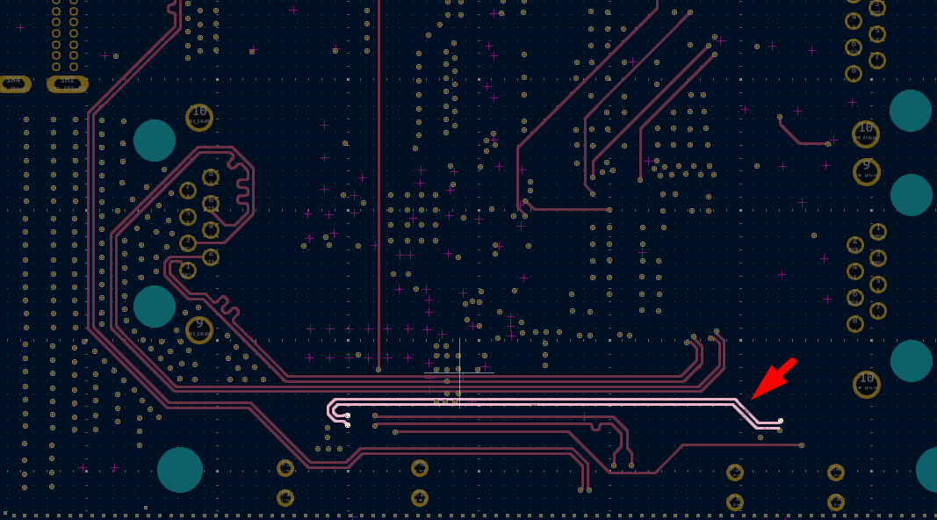

It’s necessary to apply 90ohm impedance control to the following USB traces on the layer5(signal2), layer8(B.Cu).

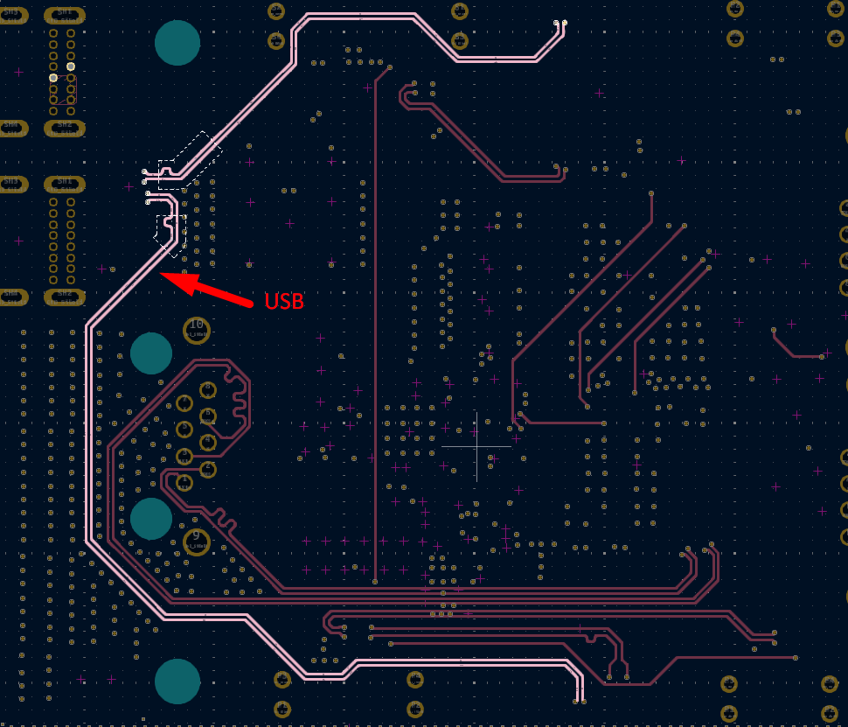

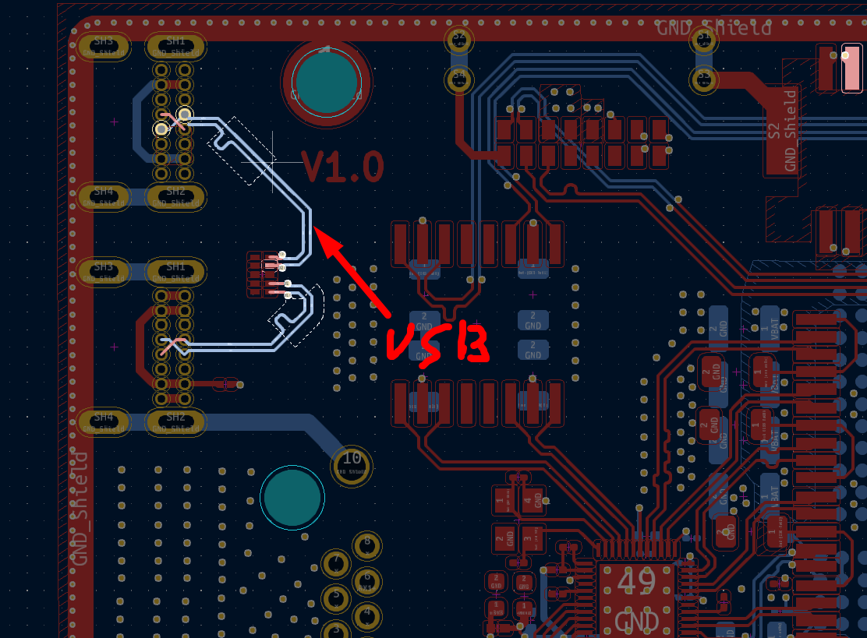

* Assembly

Pin1 indicators

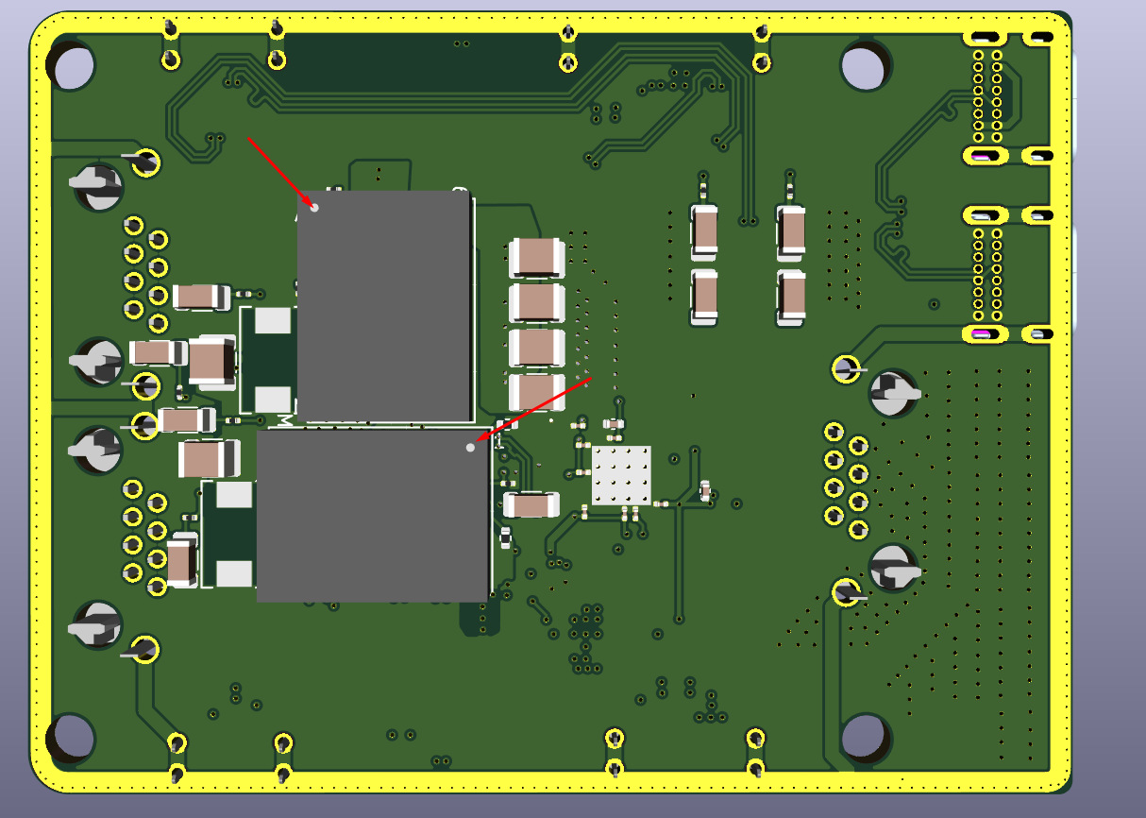

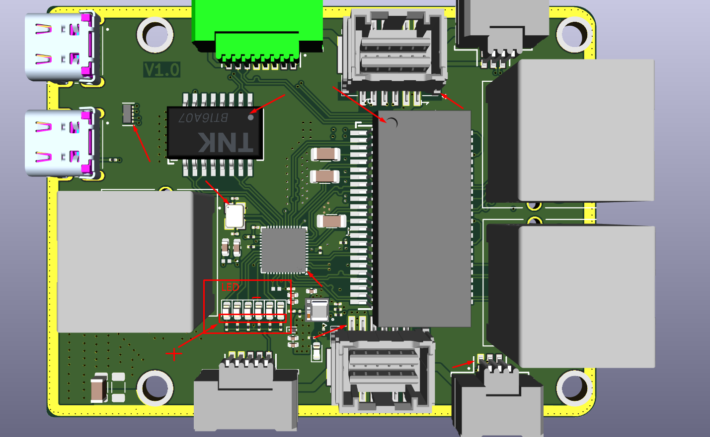

Drawings

